Website report: Diarmuid Coyne-s00250978

GitHub URL(webpage): <https://diarmuidcoyne.github.io/Project/index.html>

GitHub page: <https://github.com/DiarmuidCoyne/Project>

Rough sketch of layout:

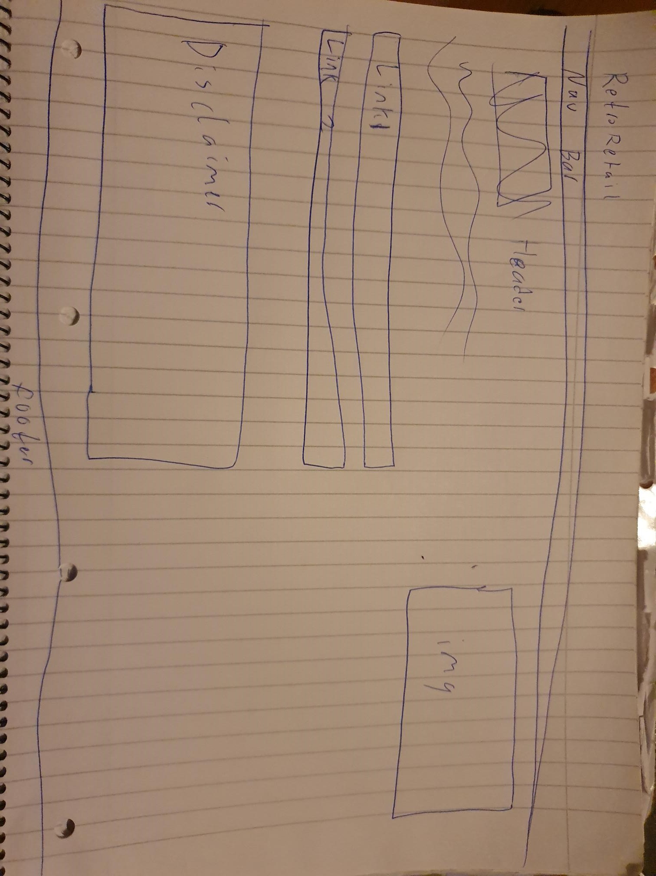

Description of pages and website:

The concept of RetroRetail is a buyer and distributer of old gen video game consoles, similar to the well known shop Cex.

The home page is a brief description of what the purpose of the website is, navigation to other pages and a disclaimer that this is a college project not a real console distributor.

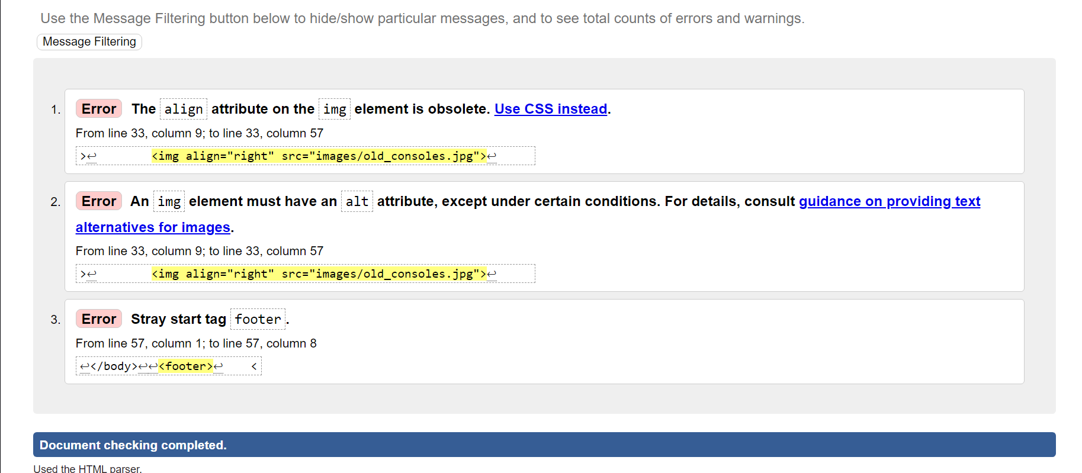

The Sega/Nintendo page is focused on providing listings of available devices produced by both Sega and Nintendo, both of these had information gathered from listings of produced consoles by both companies from Wikipedia.

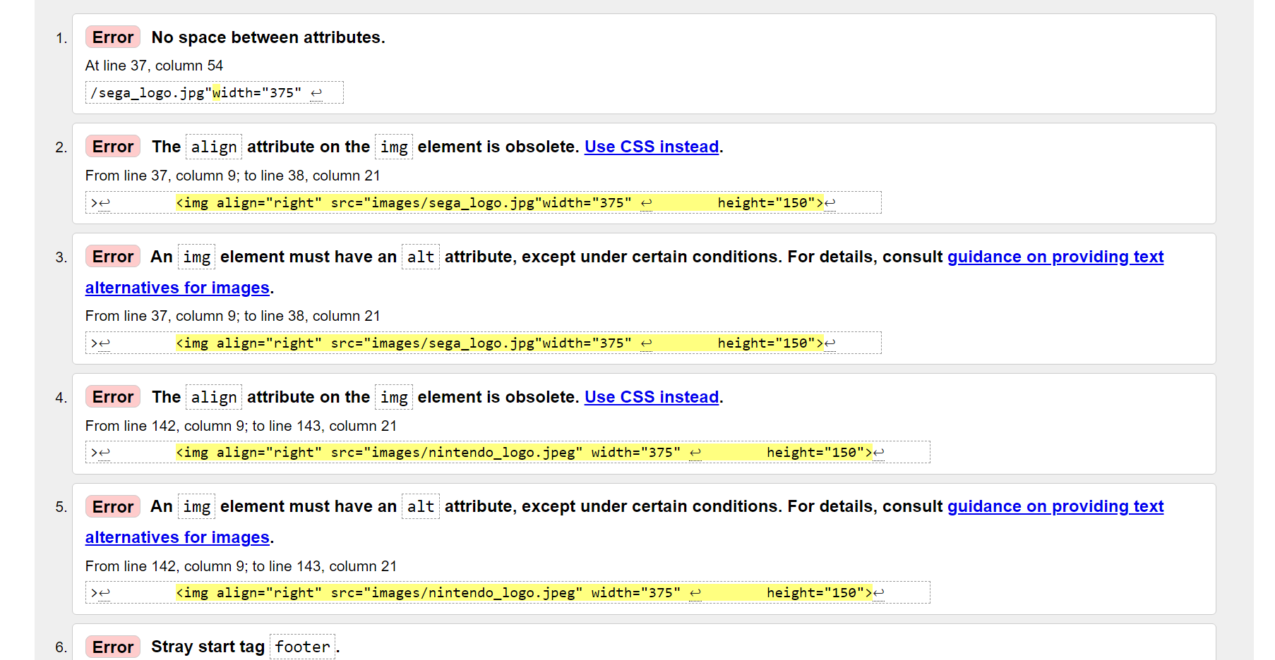

The other consoles page is used for the same purpose as the Sega/Nintendo page however it is used for listing consoles not made by either company. Sourced from Wikipedia listings of all consoles ever made.

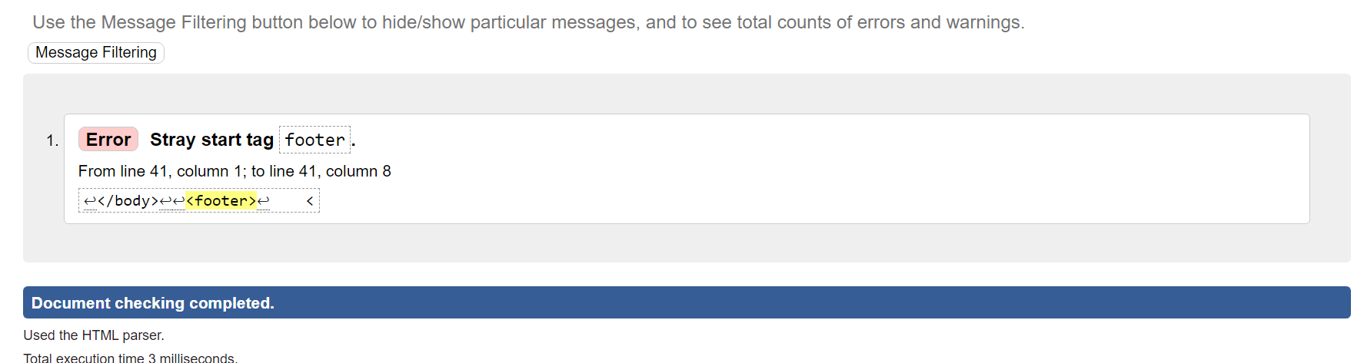

The contact page is for emailing the company to either purchase or request a device, along with information on where to find all social media platforms.

